# **Plain Language Summary (worked example)**

# **How is the size of the brain affected by a stroke or in dementia?**

[Date]

**The purpose of this plain language summary is to help you understand the findings**

**from recent research project (study)**

* Before a new treatment can be given to patients, many studies need to be done.
* This summary reports the results of one study.
* The results of this study apply to only people like those in the study. Results may not be the same for people with other types of [disease].

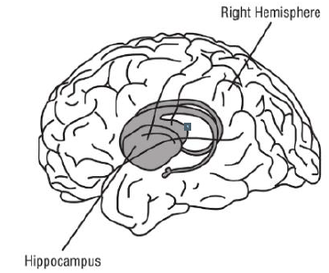

* As we age, neurons (brain cells) die naturally and this causes our brain to shrink
* The hippocampus is found in the middle of the brain; its function is for learning and memory
* Hippocampus shrinkage is a sign of brain damage. The more your brain shrinks the more likely you are to develop dementia.

**Background to this study**

Simplified diagram of the brain

**What did the study look at?**

**Why was the study done?**



* This study looked at hippocampus sizes in different groups of people over the age of 75.
* They either were: healthy (no dementia or stroke), had dementia, had a stroke, or had both a stroke and dementia. We then did a brain test on each person to look at their brain function.



* To see if there were differences in size of the hippocampus in the brain in people who had different types of dementia.
* This study aimed to find out if shrinkage in the hippocampus varied in these different groups of people.

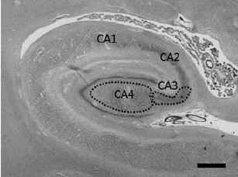The hippocampus under a microscope



We found that:

* People with stroke and dementia had lower brain test scores than those who did not have a stroke or dementia.
* The size of the hippocampus was smallest in people who had dementia compared to the people who did not have a stroke or dementia.
* As the brain function test score lowered so did the size of the hippocampus.

**What were the results**

|  |  |
| --- | --- |
|  | **How to use this summary to help patients talk to their doctors about this research**   * Question for patient to doctor. How important is this research to my care? * Question from doctor to patient. How relevant is this research to what matters most to you? |

**Who led the study?**

**Are any further studies planned?**



* Details of organisation (sponsor)
* Details of investigator



* There are no plans for further studies

**Further Information**

* Further details: ID number start and end dates
* Further educational resources
* The full title of the article is:
* Links to article